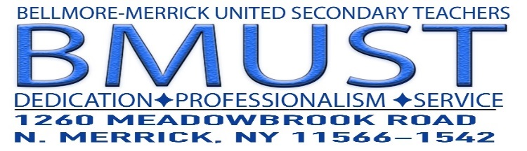
(516) 992-1068

Mark Steinberg, President
Rob Walsh, 1st Vice-President
Peter Brideson, 2nd Vice-President
Brad Seidman, Treasurer

Dear All,

Today is 5/29, which is “National 529 College Savings Plan Day”

If you have a not already created a 529 College Savings Plan, here is a link for the NYS
Plan. The NYS plan is widely recognized as one of the best plans for low costs, investment options and return. NYS also provides a savings off your NYS income tax when filing.

The enrollment form is very quick and easy to complete. The funds can be taken directly from your checking or savings account. Currently, we do not have a payroll deduction option.

All the best,
Pete Brideson
Second Vice President for Membership Services

