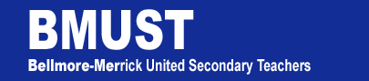
1260 Meadowbrook Road
North Merrick, NY 11566
(516)992-1068
Mark Steinberg, President

To: All Members
From: Dan Vessely, Election Chair
Kennedy HS
Date: October 10, 2017
Subject: Election Timetable for Delegates to NYSUT RA (Revised)

___________________________________________________________________________
Announcement of election for up to 5
Delegates to the NYSUT RA Convention Tuesday, October 10, 2017

___________________________________________________________________________
Nominating petitions for delegates to the
NYSUT RA Convention will be available
in the Union Office or on the BMUST website
at www.bmust.org
20 Signatures required
Begin collecting signatures on Tuesday, October 17, 2017
___________________________________________________________________________
Nominating petitions along with candidate
biographies are due in the union office
with a copy to Dan Vessely at Kennedy HS
by 3pm Tuesday, October 24, 2017
__________________________________________________________________________
Name of candidates to be announced and
biographies to be distributed. Wednesday, October 25, 2017
___________________________________________________________________________
Election of the delegates if more than 5 Tuesday, November 7, 2017
Nominees.

___________________________________________________________________________

